SOLVENT SUBSTITUTION EVALUATION OF LIMESTONE WATER AS A MEDIUM FOR BENZOYLATION
*Deepak Chowrasia, Nisha Sharma
University Institute of Pharmacy, CSJM University, Kanpur-208024, India
*E-mail: chowrasia.deepak@gmail.com
+91-9451-019049

- PHOTOGRAPHS OF SYNTHESISED COMPOUNDS WITH THEIR SUB-CODING
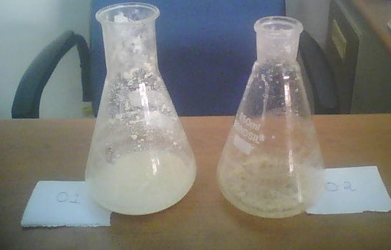
Fig. 01: Compounds 1a & 1b

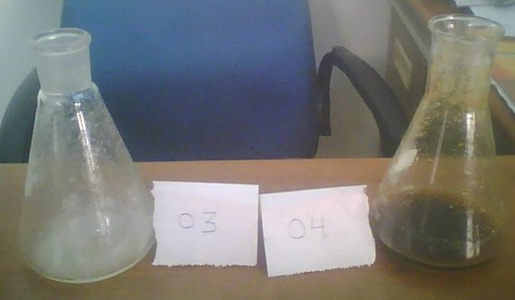
Fig. 02: Compounds 1c & 1d

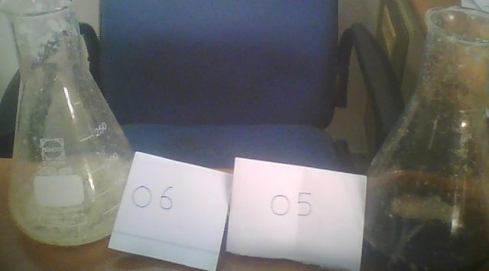
Fig. 03. Compounds 1d &1e
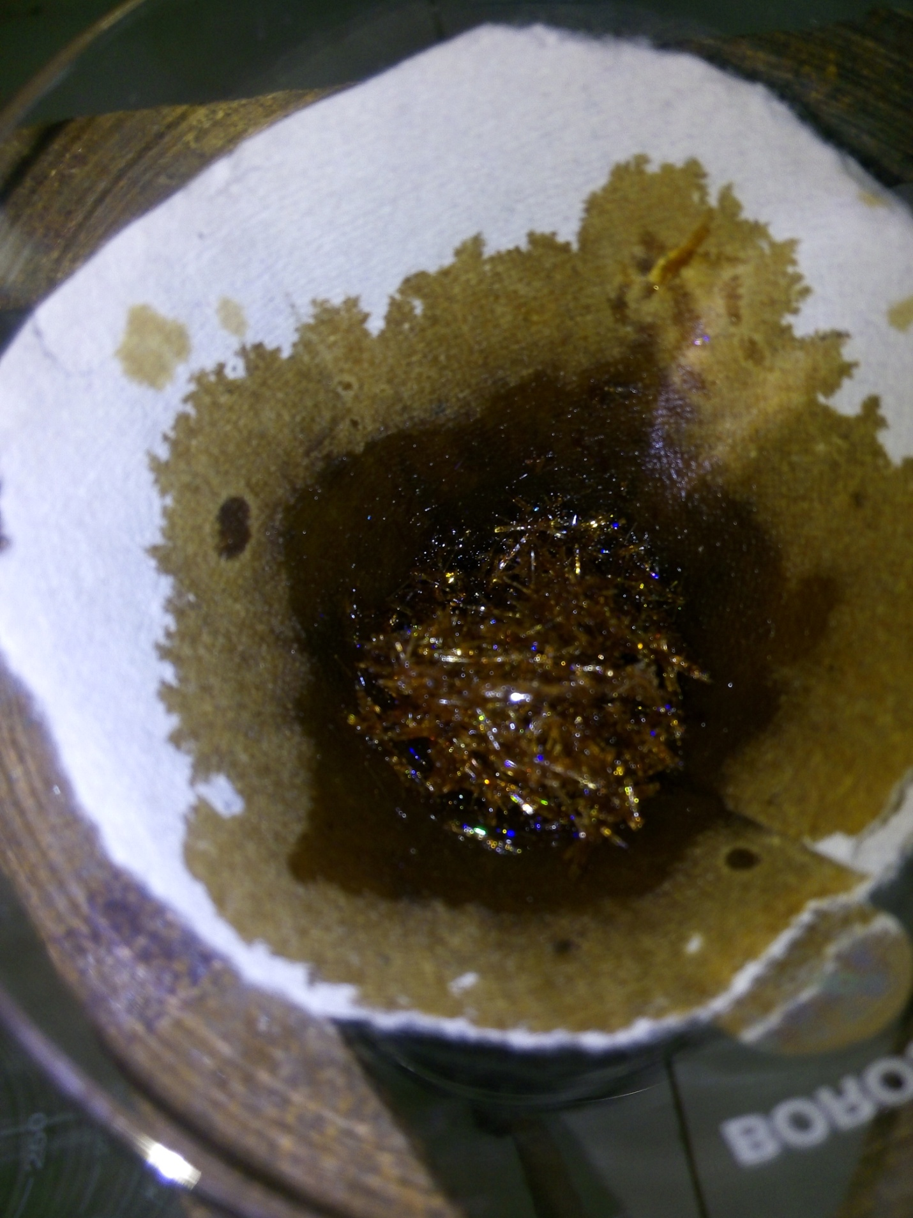
Fig. 04. Compound 1f (after filtration)

S,No | Sub-coding | Main coding
1 | 1 | 1a
2 | 2 | 1b
3 | 3 | 1c
4 | 4 | 1d
5 | 5 | 1e
6 | 6 | 1f
7 | 7 | 1g
Table 01: Decoding of above mentioned compounds

- PHOTOGRAPHS OF LIMESTONE USED TO PREPARED LIMESTONE WATER

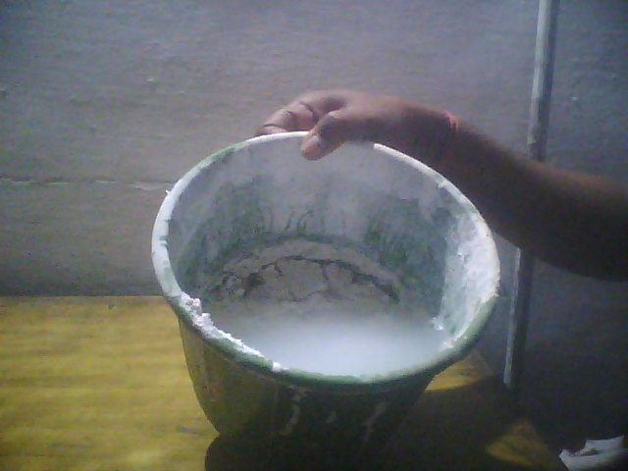
Fig.05. Generalized depiction of prepared limestone water (the photograph indicates its ease of preparation even in remote locations)
epared limestone water

- SYSTEMATIC ELEMENTAL ANALYSIS OF SYNTHESISED COMPOUNDS
Elemental analysis of synthesised compounds were done by adopting standard protocol in lab, pictorial depiction of same was given in pic 01 and 02

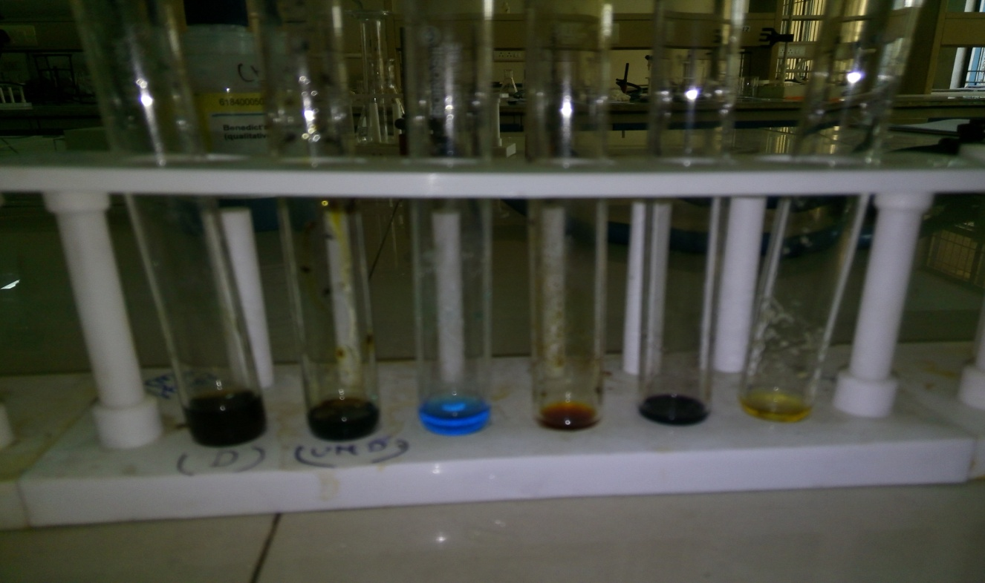
Fig.06: Specific color indicate presence of particular element in synthesised compounds (different test tube indicates different/same results under differential estimation)

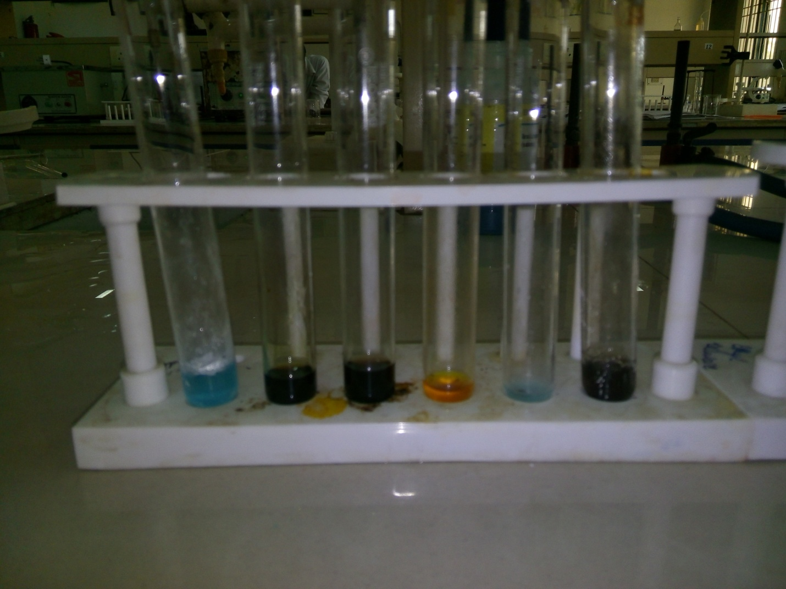
Fig.07: Specific color indicate presence of particular element in synthesised compounds (different test tube indicates different/same results under differential estimation)

04. LIST OF CHEMICALS USED INCLUDING THEIR INDUSTRIAL SPECIFICATIONS
Chemicals | Batch nos | Manufacturer | Miscellaneous
Benzoyl chloride | HC4H540178 | Merk India ltd Mumbai-18 | CAS-98-88-4
Phenol | AF3AF53187 | Merk India ltd Mumbai-18 | Bar cde-8-901089178470
Aniline | R12RF52116 | Merk India ltd Mumbai-18 | Bar cde-8-901089012613
1-naphthol | G002-0700-2806-13 | Sd fine chem. Ltd  Mumbai-25 | -
2-naphthol | G697909 | Lobachemie pvt ltd  Mumbai-05 | CAS-135-19-3
4-hydroxy acetanilide | 10030415V | Yarrow chem. Product Mumbai-01 | CAS-103-90-2
Vanillin | 0000247162 | Himedia labs pvt. Mumbai-86
Resorcinol | 691709 | Lobachemie pvt ltd  Mumbai-05 | CAS-108-46-3

05. PROCEDURE FOR CALCULATING REACTION TIME
Blank time BT₁, (not included): Preparation of reagents and reactant including initial addition of benzoyl chloride into the reaction mixture.

Time (T1)= Complete addition of benzoylchloride into reaction mixture
Time (T2) = Disappearance of benzoyl chloride odour/Formation of product
Net time= T2-T1

Blank time BT₂ (not included): Filtering, washing, drying, recrystallization of product.

- Procedure for calculating melting point
Temperature at which product start melting= T1
Temperature at which product melts completely= T2
Melting point Ta= T1+T2/2
Melting point= Ta.
Furthermore melting point of same compound was measured twice (1+2=3) and their mean was calculated to report valid m.p. of each.
Final melting point= Ta+Tb+Tc/3
The same procedure was followed in determining the melting point of all compounds reported in manuscript.

